**HTOO NAUNG WEINT**

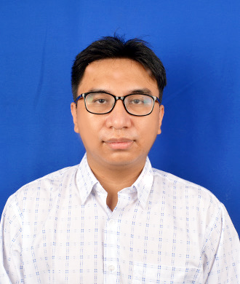

htoonaungwintmm@gmail.com  (+959) 421-122-893

**WORK EXPERIENCE**

**DAT (Daiwa Institute of Research Group) May 2019 – May 2022**

*Programmer*

DAIWA INSTITUTE OF RESEARCH provides each of the companies of the Daiwa Securities group with research information and system solution services, as well as providing a professional consulting service function in the Daiwa Securities group, concerning the financial and capital markets https://www.diracetechnology.com/index.html.

* As programmer, me and my team must develop or improve various tools and scripts for both existing and new applications. Such as
  + Payment system implementations to jlpt management system.
  + Various bug fixing for Share Holder Management System.
  + Maintenance of monitoring tool( Zabbix )
* Core responsibility #3. Pretend this is where they stop reading your resume. Whether Work or Education is your top section, the first 3 things they see better be your most impressive stuff, period.
* Core responsibility #4. Bullets #1 and #2 are for high-level descriptions of the company and/or your role.

**EDUCATION**

**University of Technology, Yadanabon Cyber City Feb, 2017**

*B.E, E.c.E Pyinoolwin, Mandalay Region*

**SKILLS & INTERESTS**

* **Skills** *html, Css, Javascript, Java, Python, Nodejs, mongoDB, MySQL …*
* **Interests** *(make your own)***:** *digital art and design, web development, video games and watching animation.*



